

MINOR-2 PROJECT

SYNOPSIS REPORT

Real-Time Product Availability Notification System

Submitted By

|  |  |  |
| --- | --- | --- |
| **Specialization** | **SAP ID** | **Name** |
| B.Tech-CSE Spl. CYBER SECURITY AND FORENSICS | 500085061 | Raghav Tiwari |
| B.Tech-hons. CSE Spl. CYBER SECURITY AND FORENSICS | 500086935 | Parv Kumar Singhal |

Department of Systemics School Of Computer Science

UNIVERSITY OF PETROLEUM & ENERGY STUDIES,

DEHRADUN- 248007. Uttarakhand

**Ms. Shahina Anwarul Dr. Neelu Jyoti Ahuja**

# Project Guide Cluster Hea

# Project Title:

# Real-Time Product Availability Notification System

# Abstract

# The "Online Product Availability Tracking Web Application" project involves the creation of a user-friendly web application hosted on a local server. It allows users to effortlessly monitor the availability status of Online store products of their choice, providing an interactive platform for managing their product preferences. This document outlines the project's objectives, methodology, and key features, highlighting the advantages it offers to users and discussing potential future enhancements.

# Introduction

# The "Online Product Availability Tracking Web Application" represents a significant step forward in providing users with a convenient and efficient means of tracking the availability of Online store products. The project extends its capabilities by introducing a user-friendly web interface. This interface allows users to input Online store product link, manage their tracked products, and receive real-time availability status updates.

# Problem Statement

The existing Online store Product Availability Checker Script lacks a user-friendly interface and automation features, making it challenging for users to monitor product availability efficiently. Users often resort to manual checks, resulting in time-consuming and tedious tasks. This project aims to address these shortcomings by developing a web application that simplifies the process of tracking product availability and enhances the user experience.

# Project Objectives

# The primary objectives of the "Online Product Availability Tracking Web Application" are as follows:

# Web Application Interface: Design and develop a user-friendly interface for inputting Online store product ASINs, managing tracked products, and receiving real-time availability updates.

# User Account Management: Implement user registration, login, and personalized tracking lists to enhance user experience and security.

# Interactive Dashboard: Create an intuitive dashboard to display tracked products and their current availability status, allowing users to manage their preferences easily.

# Customizable Notifications: Enable users to customize notification preferences, including email notifications, SMS alerts, or in-app notifications when tracked products become available.

# Scheduled Monitoring: Leverage the schedule library for scheduled availability checks, automating the process without manual intervention.

# Methodology

# The project's methodology involves several key steps:

# User Interface Design: Develop an intuitive and visually appealing user interface for the web application, ensuring ease of use.

# User Account Management: Implement user registration, login, and tracking list management to provide a personalized experience.

# Dashboard Development: Create an interactive dashboard that displays tracked products and their availability status in real time.

# Notification Customization: Develop a notification system that allows users to select their preferred notification method (email, SMS, in-app) and customize their alerts.

# Scheduled Monitoring: Utilize the schedule library to automate availability checks, ensuring users receive up-to-date information.

1. **PERT Chart**

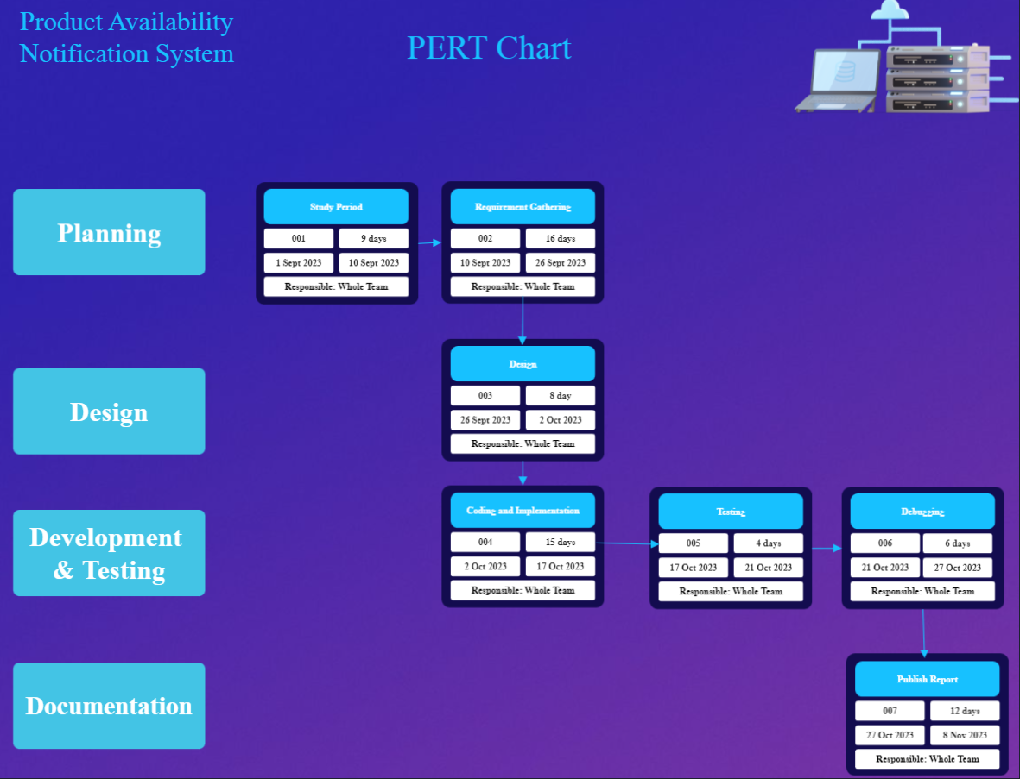

1. **Flowchart:**

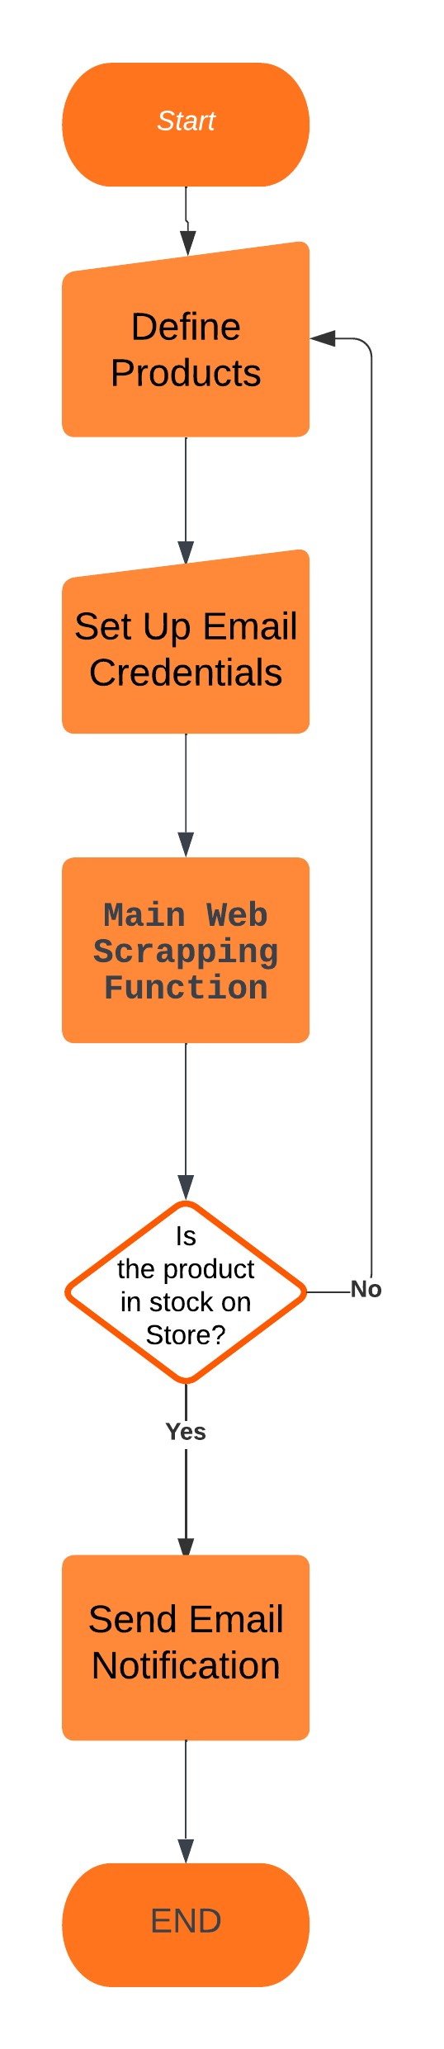

1. **Literature Review**

The proposed "Online Product Availability Tracking Web Application" aims to improve upon existing Online store Product Availability Checker Scripts by introducing a user-friendly web interface, automation features, and customizable notifications. The literature review highlights the importance of user interface design, user account management, interactive dashboards, customizable notifications, and scheduled monitoring in the development of a successful Online Product Availability Tracking Web Application. Several studies have explored the design and development of user-friendly interfaces, secure user authentication and authorization, password policies, interactive dashboards, notification systems, and scheduling systems. The studies proposed frameworks for developing these features that are visually appealing, easy to use, customizable, context-aware, reliable, efficient, and scalable. The proposed web application aims to address the shortcomings of existing scripts by incorporating these features. By doing so, it will provide users with a more efficient and user-friendly way to track product availability on Online store.

# References

1. S. Kim and J. Lee, "The impact of interface design on user experience in mobile commerce," Journal of Business Research, vol. 69, no. 9, pp. 3563-3569, 2016.
2. J. Nielsen, "Usability engineering," Academic Press, 1993.
3. S. Chaudhary and S. K. Singh, "A framework for secure user authentication and authorization," Journal of Network and Computer Applications, vol. 36, no. 1, pp. 111-123, 2013.
4. M. E. Zurko and L. F. Cranor, "Passwords: past, present, and future," IEEE Security & Privacy, vol. 2, no. 1, pp. 42-49, 2004.
5. S. Few, "Information dashboard design: displaying data for at-a-glance monitoring," O'Reilly Media, Inc., 2013.
6. K. Dey, "Understanding and using context," Personal and Ubiquitous Computing, vol. 5, no. 1, pp. 4-7, 2001.
7. M. A. Vouk, "Cloud computing - issues, research and implementations," Journal of Computing and Information Technology, vol. 16, no. 4, pp. 235-246, 2008.